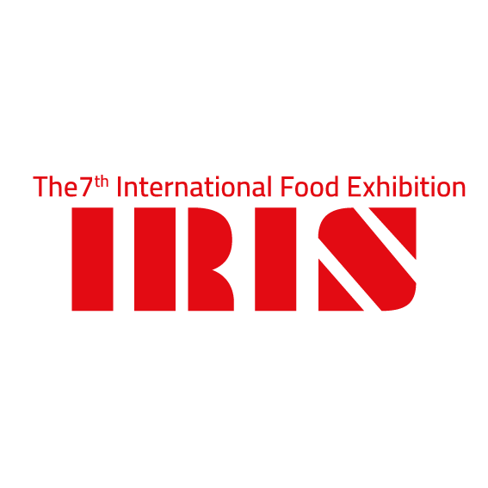
Application Form
Name of the Competitor
Job Title : |  | Employed at :
Date of Birth: |  | ID Number :
Mailing Address (street): |  | Email :
Tel: |  | Mobile:
Member in JCA: |  | Country:
Note: Incomplete applications will not be considered, please tick the category(s) you would like to compete in:
CATEGORIES

Live Cooking Competitions |  | Pastry Competition
 | Meat Dis Competition |  | Black Pox’s )western sweets) Competition
 | Pizza Competition |  | Arabic Sweet Competition
 | Best Burger Challenge Meat |  | KONAFA
 | Sandwich challenge (cold & hot) |  | BALAVA
 | Market Basket
 | Contemporary Jordanian Cuisine
 | Seafood Dish
 | Pasta Competition
PAYMENT DETAILS

Fees: 50.00JD per category for JCA members
75.00JD per category for non-members
Prices Exclude 16% tax
All Payment have to be paid in cash, or bank transfer to the order of:
The Technical Consultancy Center - JORDAN AHLI BANK-CORPRATE BRANCH
Account No: 1005392027
By signing the present application, I formally agree to abide by competition Rules & Regulations stated on the IRIS Expo 2020
NOTE: Registration Deadline for all competitions is on March 31, 2020
-------------------------------------------------------------
Signature & Company Stamp (stamp is compulsory

